

Scenario 1

1. Functional decomposition diagram

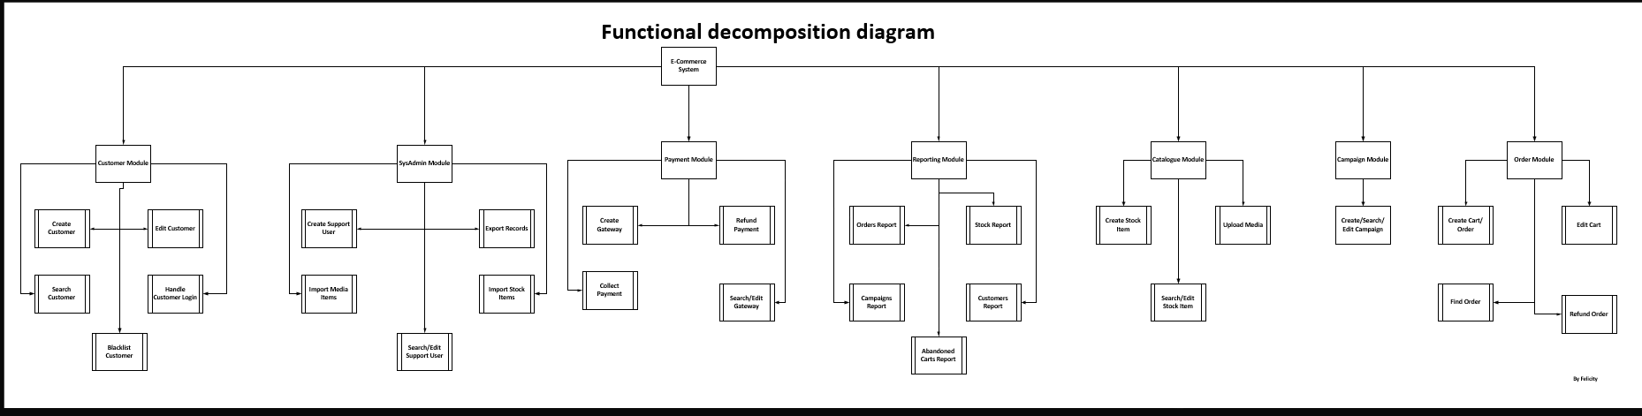

1. User interface(s) / mock-up

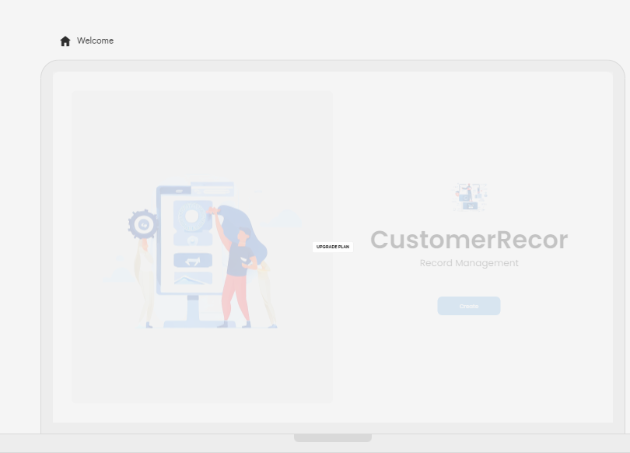

1. Entity relationship diagram

Scenario 2:

Process to gather information and detail user stories and acceptance criteria:

1. Conduct an initial meeting with the client (University of Pretoria) to understand the overall context and objectives of the e-student system enhancement project.

2. Gather and review any existing documentation or requirements related to the current e-student system.

3. Identify the key stakeholders (e.g., students, faculty, IT staff) and schedule individual or group interviews to understand their specific needs and pain points.

4. During the stakeholder interviews, ask open-ended questions to elicit detailed information about the desired functionality, user workflows, and any existing pain points or challenges.

5. Observe and document the current user workflows and processes related to the identified requirements (e.g., purchasing parking passes, viewing exam schedules, buying food vouchers).

6. Analyse the gathered information to identify user personas, user stories, and acceptance criteria.

7. Collaborate with the development team to clarify any technical constraints or feasibility concerns related to the proposed requirements.

8. Validate the user stories and acceptance criteria with the key stakeholders to ensure alignment and gather any additional feedback.

9. Document the user stories and acceptance criteria in a format that can be easily understood and used by the development team.

2. Questions to ask the customer for the user stories and acceptance criteria related to RFP Requirement No. 1:

1. What are the different types of parking passes that students can purchase (e.g., daily, weekly, monthly)?

2. What are the pricing and payment options for the parking passes?

3. How do students currently purchase parking passes (e.g., in-person, over the phone, online)?

4. What are the pain points or challenges that students face when purchasing parking passes?

5. What information do students need to provide when purchasing a parking pass (e.g., student ID, vehicle details, payment information)?

6. How should the online parking pass purchase process be designed to provide a seamless user experience for students?

7. What are the key steps in the parking pass purchase workflow (e.g., selecting pass type, entering payment details, receiving confirmation)?

8. What are the security and fraud prevention measures that need to be considered for the online parking pass purchase process?

9. How should the system handle situations where a student needs to cancel or refund a purchased parking pass?

10. What are the reporting and administrative requirements for the parking pass purchase functionality (e.g., generating sales reports, managing pass inventory)?

By gathering this information, I can develop detailed user stories and acceptance criteria that address the specific needs and requirements for the online parking pass purchase functionality.

What are the specific requirements for the online monthly parking pass functionality?

What are the user expectations and acceptance criteria for purchasing the monthly parking passes?

How should the system handle the purchase flow, payment, and issuance of the parking passes?

What are the reporting or administrative requirements for the monthly parking pass functionality?

Are there any specific security, accessibility, or usability requirements for this feature?

Scenario 3:

1. The business analyst's role in each stage of the Software Development Life Cycle (SDLC) based on the Website Services Inc. quotation is as follows:
2. Requirements Gathering and Analysis:

* This is the first stage whereby the business analyst (BA) will work closely with the client to understand their business requirements, objectives, and pain points.
* The BA will gather detailed information about the client's existing systems, processes, and any specific requirements for the new website.
* The BA will document the requirements, user stories, and acceptance criteria to ensure a clear understanding of the project scope.

1. Design and Architecture:

* The technical team and the business analyst will work together to convert the business requirements into an in-depth system design and architecture.
* To make sure that the design satisfies the demands of the customer or meets the customer requirements, the BA will offer feedback on workflow, user interface design, and overall system functionality.
* To make sure the design artifacts—such as wireframes and prototypes—meet the client's requirements, the BA will examine and validate them.

1. Development and Implementation:

* The BA will act as a liaison between the client and the development team, answering questions and offering advice as required.
* The BA will participate in code reviews, user acceptance testing, and other quality assurance activities to ensure the developed system meets the specified requirements.
* The client and the BA will work together to decide on and document the testing scenarios and user acceptance criteria.

1. Testing and Deployment:

* To ensure that the system performs as planned, the BA will work with the testing team to create and execute all the test plan.
* The BA will work with the client to conduct user acceptance testing and gather feedback on the deployed system.
* Any issues or errors found during testing will be documented by the BA, who will collaborate with the development team to find solutions.

1. Maintenance and Support:

* The BA will then provide ongoing support to the client, addressing any questions or issues that arise during the system's operation.
* The BA will gather feedback from the client and users and use this information to identify opportunities for system enhancements or improvements.
* The BA will work with the client to prioritize and plan for future system updates or feature additions.

Throughout the SDLC, the business analyst plays a crucial role in bridging the gap between the client's business requirements and the technical implementation, ensuring the delivered solution meets the client's needs and expectations.

2.

Project Name: Website Development for Client

**Project Objectives:**

* Develop a new website that meets the client's business requirements and objectives.
* Ensure the website is user-friendly, visually appealing, and optimized for performance.
* Integrate the website with the client's existing systems and processes.

**Project Scope:**

* Design and develop a new website with the following key features:
* Content management system.
* E-commerce functionality
* Integration with third-party payment gateway
* Search engine optimization
* Mobile-responsive design
* Provide training and documentation for the client's team on website management and maintenance.

**Project Timeline:**

- Phase 1 (Requirements Gathering and Design): 5 weeks

- Phase 2 (Development and Implementation): 9 weeks

- Phase 3 (Testing and Deployment): 3weeks

- Phase 4 (Training and Documentation): 1 week

- Total Project Duration: 17 weeks

**Project Milestones:**

1. Kick-off meeting and requirements gathering: Week 1

2. Completion of design and wireframes: Week 5

3. Completion of development and integration: Week 13

4. User acceptance testing and deployment: Week 15

5. Training and documentation handover: Week 16

**Project Resources:**

* Project Manager
* Business Analyst
* User Experience Designer
* Front-end Developer
* Back-end Developer
* Quality Assurance Tester

**Project Risks and Mitigation Strategies:**

* Scope creep: Clearly define and manage the project scope, obtain client sign-off on changes.
* Delays in client feedback or approvals: Establish regular communication and review cadence with the client.
* Technical integration challenges: Conduct thorough analysis and planning for system integrations.
* Resource availability: Ensure adequate staffing and plan for potential resource constraints.

**Project Budget:**

* Total project cost: R100,0000 (as per the Website Services Inc. quotation)

Scenario 4:

Entity name: CUSTOMER

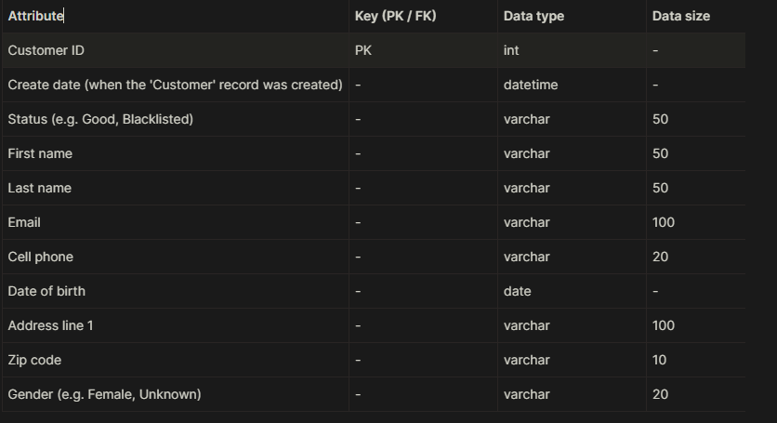

Entity name: ORDER

